ReadWriteLock读写锁

# ReadWriteLock接口--读写锁

## ReadWriteLock接口

public interface ReadWriteLock

ReadWriteLock接口与Lock接口并列(不是继承哦)，存在于java.util.concurrent.locks包中，有1个实现类：**ReentrantReadWriteLock**可重入的读写锁。

## 功能介绍

A **ReadWriteLock** maintains a pair of associated locks, one for *read-only operations* and one for *writing*. The read lock may be held simultaneously **by multiple reader threads**, so long as there are no writers. The write lock is **exclusive**.(读与写是互斥的)

All **ReadWriteLock** implementations must guarantee that the memory synchronization effects of writeLock operations (as specified in the Lock interface) also hold with respect to the associated readLock. That is, a thread successfully acquiring the read lock will see all updates made upon previous release of the write lock.

A **read-write lock** allows for a greater level of concurrency in accessing shared data than that permitted by a mutual exclusion lock. It exploits the fact that while only a single thread at a time (a writer thread) can modify the shared data, in many cases any number of threads can concurrently read the data (hence reader threads). In theory, the increase in concurrency permitted by the use of a read-write lock will lead to performance improvements over the use of a mutual exclusion lock. In practice this increase in concurrency will only be fully realized on a multi-processor, and then only if the access patterns for the shared data are suitable.

## 接口方法2个

ReadWriteLock接口只规定了2个方法：readLock()和writeLock()方法。

Lock **readLock**() Returns the lock used for reading.获取读锁

Lock **writeLock**() Returns the lock used for writing.获取写锁

## 读锁与写锁

读锁，此时多个线程可以同时获得读锁；写锁，此时只有一个线程能获得写锁；

所有的读锁释放后才执行写锁的方法，说明读锁和写锁是互斥的。

**ReadWriteLock：读读共享，写写互斥，读写互斥**。

# ReentrantReadWriteLock

## ReentrantReadWriteLock简单介绍

public class **ReentrantReadWriteLock** extends Object implements **ReadWriteLock**, **Serializable**.

An implementation of ReadWriteLock supporting similar semantics to **ReentrantLock**.

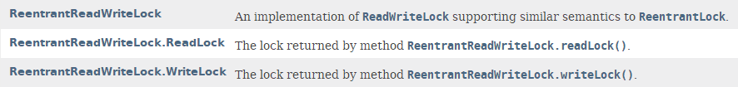

## 构造方法

**ReentrantReadWriteLock**()

Creates a new ReentrantReadWriteLock with default (nonfair) ordering properties.

**ReentrantReadWriteLock**(boolean fair)

Creates a new ReentrantReadWriteLock with the given fairness policy.

## 通过方法获取内部类：读锁与写锁

static class **ReentrantReadWriteLock.ReadLock**

The lock returned by method **readLock().**

static class **ReentrantReadWriteLock.WriteLock**

The lock returned by method **writeLock().**

通过readLock()和writeLock()方法获取：

## 方法

除了readLock()和writeLock()方法之外，其他方法与**ReentrantLock**实现的方法类似。